NUCLEAR POWER PLANT FAULT DETECTION DEVICE
Gokila S^{1,} Keerthivasan A², Lingesh L³
gokila.it@karpagamtech.ac.in, 21ita21@karpagamtech.ac.in, 21ita24@karpagamtech.ac.in
Karpagam Institute of Technology, Coimbatore
Department of Information Technology

Abstract
The safe and efficient operation of nuclear power plants (NPPs) relies heavily on the continuous monitoring and maintenance of industrial machines. Fault detection in these machines is critical to preventing failures that could lead to operational disruptions, safety hazards, and financial losses. The integration of the Internet of Things (IoT) in fault detection provides a smart, real-time monitoring system that enhances predictive maintenance and reduces downtime. The results demonstrate the effectiveness of the system in detecting faults with high accuracy, enabling proactive maintenance strategies. This approach contributes to the overall efficiency, safety, and sustainability of nuclear power plant operations.
Keywords
Nuclear Power Plant, IoT, Fault Detection, Predictive Maintenance, Machine Learning, Industrial Machines , Real-time Monitoring, Anomaly Detection, Remote Monitoring, Remote Monitoring, Condition-based Monitoring.
1.INTRODUCTION
Nuclear power plants (NPPs) play an important role in the global energy sector, providing a reliable and sustainable source and resource of electricity. However, the safety and efficiency of these plants depend on the proper functioning of complex industrial machines including turbines, pumps, heat exchangers, and cooling systems. Any malfunction in these components can lead to operational disturbance, safety risks, and significant financial losses. Traditional maintenance strategies, such as periodic inspections and reactive maintenance, are often insufficient in preventing unexpected failures. As a result, there is a growing need for advanced fault detection systems that can predict potential failures and enable proactive maintenance.
The development of a digital instrument and control (I&C) system, a large amount of operational data could be collected on the digital instrument and control(I&C) platform. The degree of digital and information of NPP is constantly improving, and the development is gradually moving towards a human-free, self-monitoring, and control plants (Jun and Zheng, 2019). However, the current intelligence in the field of operation and maintenance in NPP is insufficient, and the improvement ensured by digitization is not fully utilized. Also, the value hidden in data has not been fully explored in the nuclear industry.
  - Background on nuclear power plants and the importance of fault detection.
Nuclear power plants (NPPs) are a vital component of the global energy infrastructure, providing a significant portion of the world's electricity. These facilities generate power through controlled nuclear reactions, primarily fission, where atomic nuclei split to release large amounts of energy. The heat produced from this process is used to convert water into steam, which drives turbines to generate electricity.
Nuclear plants must operate with a high degree of safety to prevent accidents and radiation leaks. Faults in components such as pumps, control rods, or heat exchangers can compromise reactor stability. Early fault detection helps in identifying issues before they escalate, reducing the risk of catastrophic failures.
  - Overview of IoT applications in industrial settings.

The Internet of Things (IoT) is transforming industrial sectors by enabling real-time monitoring, data-driven decision-making, and automation. IoT connects physical devices, sensors, and machines to the internet, allowing them to collect, analyze, and share data autonomously. In industrial settings, including nuclear power plants (NPPs), IoT plays a vital role in improving operational efficiency, reducing downtime, and enhancing safety.

Nuclear power plants rely on numerous critical industrial machines such as turbines, cooling systems, heat exchangers, and pumps. The failure of any of these components can lead to operational disruptions, financial losses, and safety hazards. IoT-based fault detection systems help in identifying faults in real-time, predicting failures, and optimizing maintenance activities to prevent catastrophic failures.

  - Purpose and significance of integrating IoT for fault detection in nuclear power plants.

Nuclear power plants (NPPs) play a crucial role in global energy generation, providing a stable, low-carbon, and high-efficiency power source. However, their operations involve complex and sensitive industrial machinery that must function flawlessly to prevent failures, ensure safety, and optimize efficiency.
Fault detection is a critical aspect of nuclear plant operations, as undetected faults can lead to equipment damage, unplanned shutdowns, radiation leaks, or catastrophic failures. Traditional fault detection methods rely on manual inspections, scheduled maintenance, and alarm-based monitoring, which may not always identify issues early enough.

The integration of Internet of Things (IoT) technology in nuclear power plants revolutionizes fault detection by enabling real-time monitoring, predictive maintenance, and automated diagnostics. This paper discusses the purpose and significance of integrating IoT into fault detection systems in nuclear power plants.

  - Purpose of Integrating IoT for Fault Detection in Nuclear Power Plants.

Traditional fault detection methods rely on manual inspections, scheduled maintenance, and basic alarm systems. These methods are often reactive, meaning they only detect faults after they occur, which can lead to costly repairs, unplanned outages, or even hazardous accidents.

The integration of the Internet of Things (IoT) provides a proactive approach to fault detection, enabling real-time monitoring, predictive analytics, and automated diagnostics. IoT enhances the efficiency, safety, and reliability of nuclear power plants by continuously collecting, analyzing, and acting on machine health data.
2.Literature Review
2.1 Existing Fault Detection Methods in Nuclear Power Plants
Nuclear power plants (NPPs) are highly complex facilities that require continuous monitoring and fault detection to prevent equipment failures, radiation leaks, and potential disasters. Given the critical nature of nuclear power generation, fault detection methods must be highly reliable, accurate, and efficient.
Traditional fault detection in NPPs relies on manual inspections, sensor-based monitoring, and alarm systems. While these methods have been effective, they have limitations in detecting faults early, predicting failures, and minimizing downtime.
This section provides a detailed explanation of existing fault detection methods in nuclear power plants, their working principles, advantages, and limitations.

2.2 Previous applications of IoT in industrial fault detection.
The Internet of Things (IoT) has revolutionized industrial operations by enabling real-time monitoring, predictive maintenance, and automated fault detection. In nuclear power plants (NPPs), where safety and efficiency are paramount, IoT-based fault detection has emerged as a game-changing technology.
In the past, fault detection in NPPs relied on manual inspections, scheduled maintenance, and basic alarm systems. These traditional methods often led to delayed fault detection, unplanned outages, and higher maintenance costs. By integrating IoT sensors, cloud computing, AI-driven analytics, and remote monitoring, NPPs can now detect faults earlier, reduce downtime, and enhance safety measures.
This section explores previous applications of IoT in nuclear power plant fault detection, highlighting real-world implementations, case studies, and technological advancements.
2.3 Gaps in Current Research on Nuclear Power Plant Fault Detection
A. Lack of Predictive Fault Detection Models
- Most traditional and existing fault detection methods in NPPs are reactive, meaning they identify faults only after they occur.
- Alarm-based and threshold-triggered detection do not predict failures in advance.
- AI-driven predictive maintenance using IoT sensors has been explored, but not fully optimized for nuclear applications.
B. Limited Integration of IoT with Nuclear Safety Standards
- Existing IoT implementations in industrial fault detection often focus on general manufacturing and power plants, but not specifically nuclear reactors.
- Regulatory bodies such as the International Atomic Energy Agency (IAEA) and Nuclear Regulatory Commission (NRC) impose strict safety and cybersecurity standards.
- There is insufficient research on how IoT fault detection can aligned with nuclear safety protocols.
C. Insufficient Use of IoT in Multi-Sensor Fusion for Fault Detection
- Most research studies use single-sensor monitoring, such as vibration analysis, thermal imaging, or radiation detection, leading to incomplete fault diagnosis.
- Multi-sensor fusion, which integrates temperature, pressure, vibration, radiation, and acoustic data, is rarely implemented in nuclear plants.
- Without multi-sensor analysis, the accuracy of fault detection is limited, increasing false alarms or missing critical faults.
3. Design and System Implementation
3.1 System Architecture

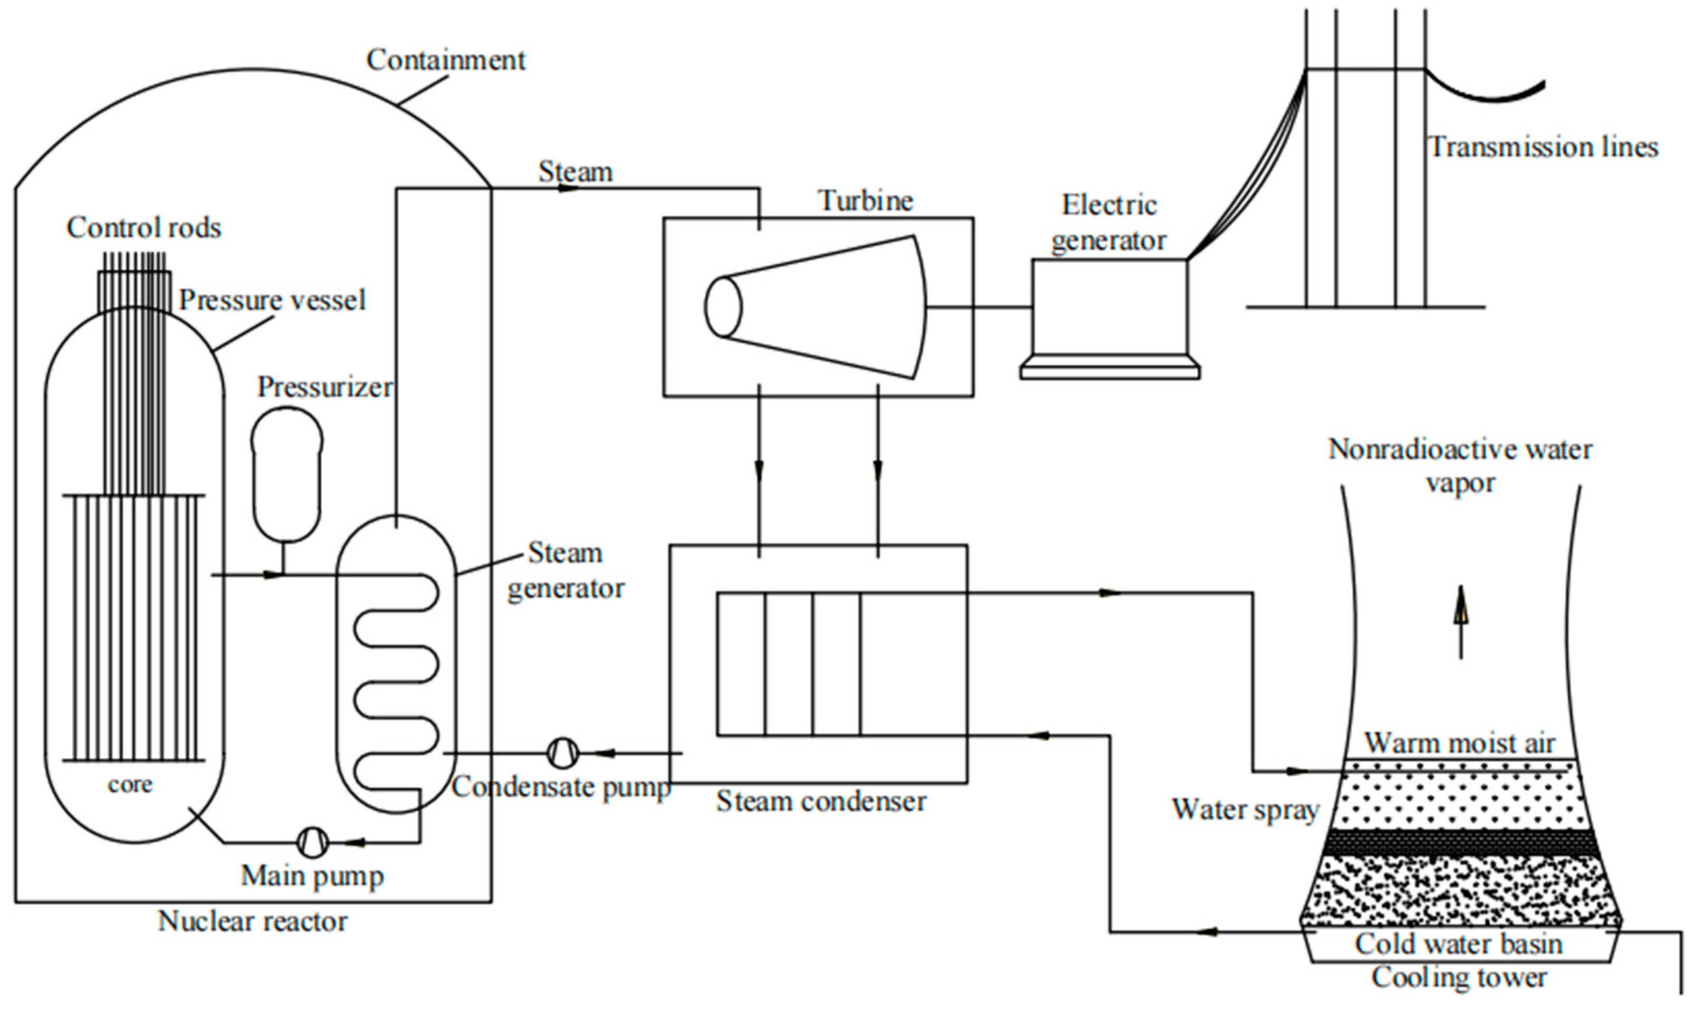

• Perception Layer (Sensor Layer)
• Network Layer (Communication Layer)
• Edge/Fog Computing Layer
• Cloud Computing Layer
• Application Layer (User Interface & Decision Making)
3.1.1 Perception Layer (Sensor Layer)
This layer comprises IoT-enabled sensors and actuators responsible for data collection in different areas of the nuclear power plant. Sensors monitor various parameters such as:
- Temperature Sensors (coolant temperature, reactor core heat)
- Pressure Sensors (reactor vessel pressure, steam pressure)
- Radiation Sensors (gamma radiation, neutron flux)
- Vibration Sensors (turbine and generator vibrations)
- Gas Sensors (hydrogen leaks, radioactive gases)
- Flow Sensors (coolant and steam flow rates)
3.1.2 Network Layer (Communication Layer)
The network layer ensures seamless communication between IoT devices, edge computers, and the cloud. The key components include:
- Communication Protocols:
  - Wired: Ethernet, Fiber Optic
  - Wireless: Wi-Fi, 5G, LPWAN, Zigbee
- IoT Gateways:
  - Aggregate data from multiple sensors
  - Perform initial data filtering

3.1.3 Edge/Fog Computing Layer
Instead of sending all data to the cloud, edge computing processes critical data near the plant location. Fog nodes (local servers) analyze real-time sensor data to detect anomalies and prevent delays in fault detection.
- Functions of Edge/Fog Computing:
  - Pre-processing sensor data (removing noise, filtering)
  - Running lightweight AI models for fault prediction
  - Sending only critical alerts to the cloud
  - Ensuring real-time response for emergency situations
3.2 Hardware Components
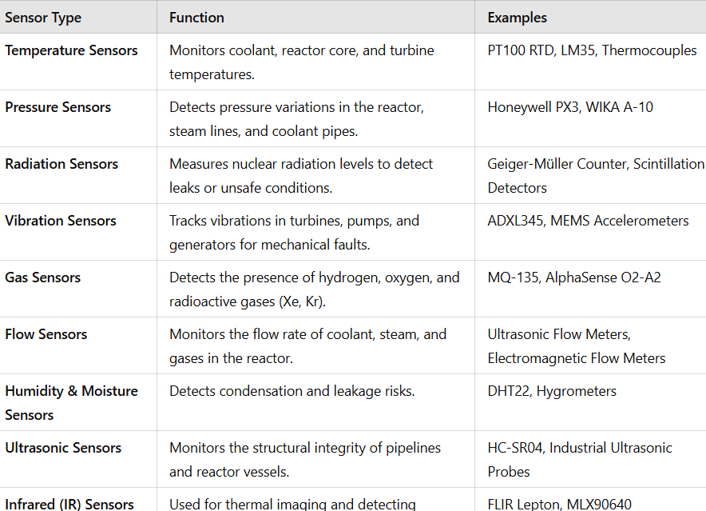
3.3 Advantages of the system
1. Real-Time Monitoring & Fault Detection
1.1 Continuous Data Collection: IoT sensors monitor critical parameters like temperature, pressure, radiation, and vibrations 24/7.
1.2 Early Fault Detection: AI-powered anomaly detection identifies potential failures before they become critical.
1.3 Faster Response Time: Alerts and notifications are sent in real-time via mobile apps, SMS, or email to plant operators.
2. Enhanced Safety & Risk Mitigation
2.1 Prevents Nuclear Disasters: Early detection of faults (e.g., coolant leaks, overheating, or radiation spikes) reduces the risk of nuclear accidents.
2.2 Automated Emergency Actions: IoT actuators can trigger automatic safety mechanisms (e.g., shutting down reactors, activating backup cooling).
2.3 Radiation Leak Detection: Continuous radiation monitoring ensures worker and environmental safety.
3. Predictive Maintenance & Cost Reduction
3.1 Reduces Maintenance Costs: AI-based predictive maintenance prevents expensive breakdowns.
3.2 Minimizes Downtime: Detecting small issues before failure avoids unscheduled shutdowns, keeping the plant operational.
3.3 Extends Equipment Lifespan: Proactive monitoring helps reduce wear and tear, increasing the life of turbines, pumps, and generators.

4. Analysis of system performance
1. Key Performance Metrics
4.1.1. Accuracy & Precision of Fault Detection
Fault Detection Accuracy (%): Measures how accurately the system identifies real faults vs. false alarms.
Precision & Recall: AI models should have high precision (low false positives) and high recall (low false negatives).
🔹 Example:
- A well-trained AI model detects faults with 98% accuracy, reducing the risk of false alerts.
- False Positive Rate (FPR) should be <5% to avoid unnecessary shutdowns.
4.1.2 Performance Improvement Strategies:
- Use Machine Learning (ML) models trained on historical fault data.
- Implement sensor fusion (combining multiple sensor inputs) to improve accuracy.
1.2. Latency & Response Time
Latency (ms): Measures the time delay between fault occurrence and detection.
Response Time (s): Measures the time taken to send an alert and trigger preventive actions.
🔹 Example:
- Traditional SCADA-based fault detection takes several minutes to analyze faults.
- IoT + Edge Computing reduces response time to milliseconds.
Performance Improvement Strategies:
- Implement Edge Computing for real-time processing.
- Use low-latency communication protocols (MQTT, CoAP, 5G, LPWAN).
4.1.3 Reliability & Fault Tolerance
System Uptime (%): The system should have >99.9% availability to ensure continuous monitoring.
Fault Tolerance Mechanism: Ensures that if one sensor fails, another takes over.
Example:
- Redundant sensors and backup IoT nodes ensure monitoring even during hardware failures.

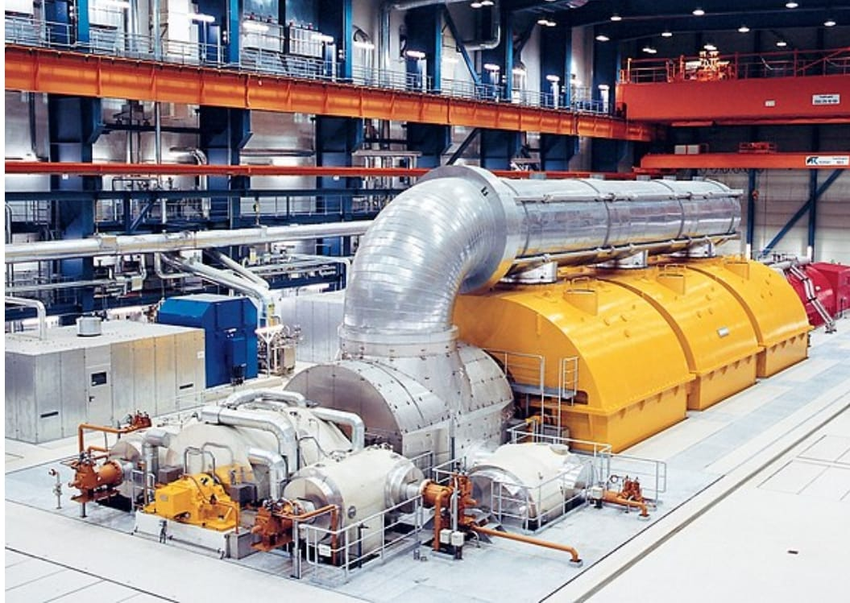

5.Methodology:
The methodology for designing and implementing an IoT-based fault detection system in a nuclear power plant involves multiple stages, including system design, data acquisition, data processing, fault detection, and response mechanisms. Below is a step-by-step breakdown of the approach.
Block Diagram:
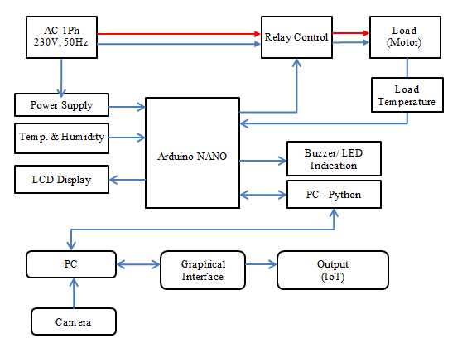
5.1 Data Acquisition & Preprocessing
5.1.1 Sensor Deployment
- Install sensors in critical plant areas: reactor core, turbines, coolant systems, steam pipelines.
- Use redundant sensors to improve reliability.
5.1.2 Data Collection
- Sensors continuously collect temperature, pressure, radiation levels, vibration, and flow rate data.
- Use Edge IoT gateways to preprocess sensor data before transmission.
5.1.3 Data Cleaning & Preprocessing
- Remove Noise – Filter out anomalies caused by sensor drift or interference.
- Normalize Data – Convert sensor readings into a standardized format.
- Feature Engineering – Extract key features (e.g., rate of change of temperature, vibration patterns).

5.2 Fault Detection & Anomaly Analysis
5.2.1 Fault Detection Methods
(A) Rule-Based Fault Detection (Threshold-Based Monitoring)
- Predefined safety thresholds for temperature, radiation, and pressure.
Example:
- If reactor temperature > 350°C, trigger high-risk alert.
(B) Machine Learning-Based Anomaly Detection
- Train AI models (e.g., Random Forest, LSTM, CNN, SVM) on historical fault data.
- Detect abnormal patterns before failure occurs.
Example:
- AI detects unusual vibration in a turbine, predicting failure 5 days in advance.
6. conclusion:
The IoT-based nuclear power plant fault detection system provides a smart, efficient, and real-time monitoring solution to enhance the safety, reliability, and operational efficiency of nuclear facilities. By integrating advanced sensors, IoT communication networks, AI-driven analytics, and cloud computing, this system enables early fault detection, predictive maintenance, and automated emergency responses. By integrating sensors, AI analytics, and cloud computing, the system helps prevent critical failures, reduces downtime, and automates emergency responses.This technology minimizes human risk, optimizes maintenance, and ensures regulatory compliance, making nuclear power plants safer and more efficient for the future.
7.Reference
- P. Singh et al.Design of safety critical and control systems of Nuclear Power Plants using Petri netsNucl. Eng. Technol.(2019)
- M. CepinEvaluation of the power system reliability if a nuclear power plant is replaced with wind power plantsReliab. Eng. Syst. Saf.(2019)
- J. Hines et al.Lessons Learned from the U.S. Nuclear Power Plant On-line Monitoring ProgramsProg. Nucl. Energy(2005)
- R. Akbari et al.Small modular reactor full scope coreoptimization using Cuckoo Optimization AlgorithmProg. Nucl. Energy(2020)
- L. Yu et al.Intelligent power monitoring of building equipment based on Internet of Things technologyComput.Commun.2020)
- D.T. Hoang et al.A survey on Deep Learning based bearing faultdiagnosisNeurocomputing(2019)
- E. Zio et al.Evolutionary fuzzy clustering for the classification of transients in nuclear componentsProg. Nucl. Energy(2005)
- C.R. Gomes et al.Neural network of Gaussian radial basis functions applied to the problem of identification of nuclear accidents in a PWR nuclear power plantAnn. Nucl. Ener.(2015)
- H. Wang et al.A hybrid fault diagnosis methodology with support vector machine and improved particle swarm optimization for nuclear power plantsISA Trans.(2019)
- B.S. Peng et al.Research on intelligent fault diagnosis method for nuclear power plant based on correlation analysis and deep belief networkProg. Nucl. Energy(2018)
- D. Lee et al.Autonomous operation algorithm for safety systems of nuclear power plants by using long-short term memory and function-based hierarchical frameworkAnn. Nucl. Energy(2018)

- Z.H. An et al.A novel bearing intelligent fault diagnosis framework under time-varying working conditions using recurrent neural networkISA Trans.(2020)
- P. Peng et al.Cost sensitive active learning using bidirectional gated recurrent neural networks for imbalanced fault diagnosisNeurocomputing(2020)

- X.B. Liang et al.Intelligent diagnosis of natural gas pipeline defects using improved flower pollination algorithm and artificial neural networkJ. Cleaner Prod.(2020)

- Y.Y. Zhang et al.A new subset based deep feature learning method for intelligent fault diagnosis of bearingExpert Syst. Appl.(2018)

- D.X. ZhouTheory of deep convolutional neural networks: DownsamplingNeural Networks(2020)

- Q. He et al.A novel artificial fish swarm algorithm for solving large-scale reliability–redundancy application problemISA Trans.2015)

- H.M. Hashemian

On-line monitoring applications in nuclear power plants

Prog. Nucl. Energy
(2011)

